**Ideation Phase**

**Define the Problem Statements**

| Date | 30/10/2025 |
| --- | --- |
| Team ID | NM2025TMID01257 |
| Project Name | Calculating Family Expenses using ServiceNow |
| Maximum Marks | 4 Marks |

**Customer Problem Statement Template:**

Creating a clear problem statement helps us understand the challenges faced by users when managing their family expenses.  
By viewing the issue from the user’s perspective, we can design a ServiceNow-based solution that is both efficient and user-friendly.  
This approach ensures that the developed system directly addresses real-life financial management problems such as manual tracking, budgeting difficulties, and lack of transparency among family members.



**Example:**

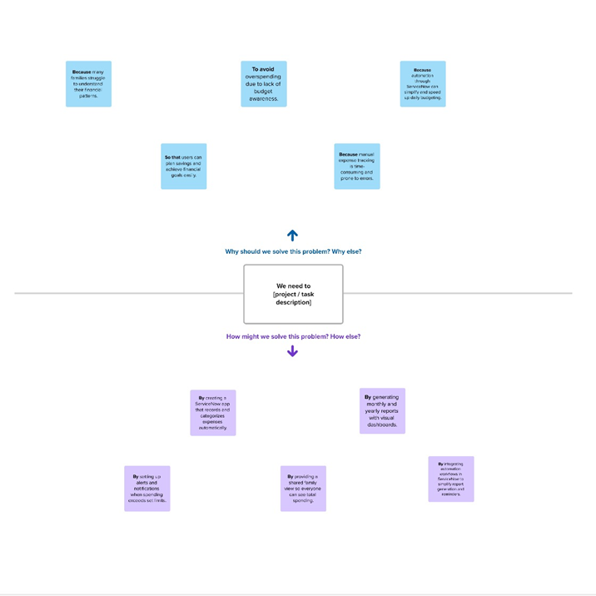

|  |  |  |  |  |  |
| --- | --- | --- | --- | --- | --- |
| **Problem Statement (PS)** | **I am (Customer)** | **I’m trying to** | **But** | **Because** | **Which makes me feel** |
| PS-1 | a working parent who manages all family expenses manually. | track and organize monthly spending to stay within budget. | keeping records manually in books or spreadsheets takes too much time and often leads to calculation errors. | I don’t have an automated system to categorize and visualize expenses. | stressed and unorganized about my family’s financial planning. |
| PS-2 | a college student living in a shared household. | manage shared expenses and split costs fairly with my roommates. | it’s hard to track who paid what and how much everyone owes. | there’s no centralized platform for expense sharing and tracking. | frustrated and unsure about my financial contribution and savings. |